Remarks to measurements on the EUT’s
Voltage and current measurements at different input voltages and output currents.
Load is pure resistive. No electronic load used during tests.

Remarks:
The internal current measurement without external load shows 210mA. This was not seen on the first prototypes with the old firmware and seems to be introduced with SW release 1.070. EUT’s with SW 1.058 do not show this issue.

Remarks
The remark above about internal measurements also applies here.

Remarks
The remark above about internal measurements also applies here.
At a load of 10 A at 14.4 Vdc and a supply voltage of 88 Vac the DC-output is not stable. We suspect this is caused by the 100 Hz ripple, that can be seen in the following measurements.

Remarks
The remark above about internal measurements also applies here.
At a load of 10 A at 14.4 Vdc and a supply voltage of 88 Vac the DC-output is not stable. We suspect this is caused by the 100 Hz ripple, that can be seen in the following measurements.

Measurements on the DC-output connector
Specification | Measured
Output Voltage ripple: <160 mV pk-pk @ full load  Mains = 230Vac.  Load 10A @ 14.5Vdc.  Measured ripple 136mVpp | 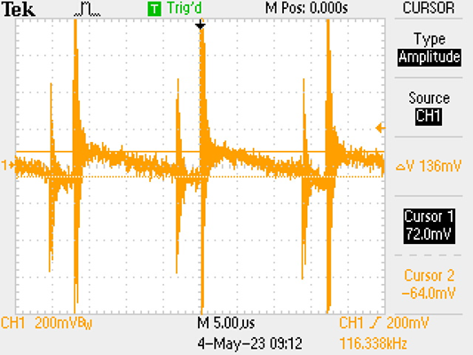
Output Noise level: <1.5Vpp (30KHz – 300KHz)  Mains = 230Vac.  Load 10A @ 14.5Vdc.  Measured noise 2.7Vpp | 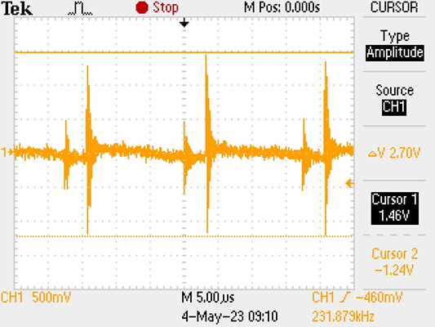
Output ripple voltage: <1.0% of nominal output voltage Over (10Hz – 100KHz)  Mains = 88Vac.  Load 10A @ 14.5Vdc.  Measured 100Hz ripple, 1.52 Vpp. | 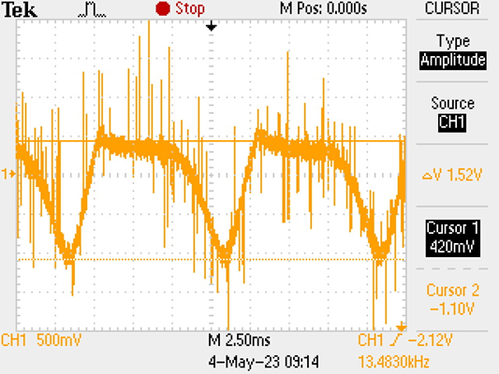

Harmonic distortion
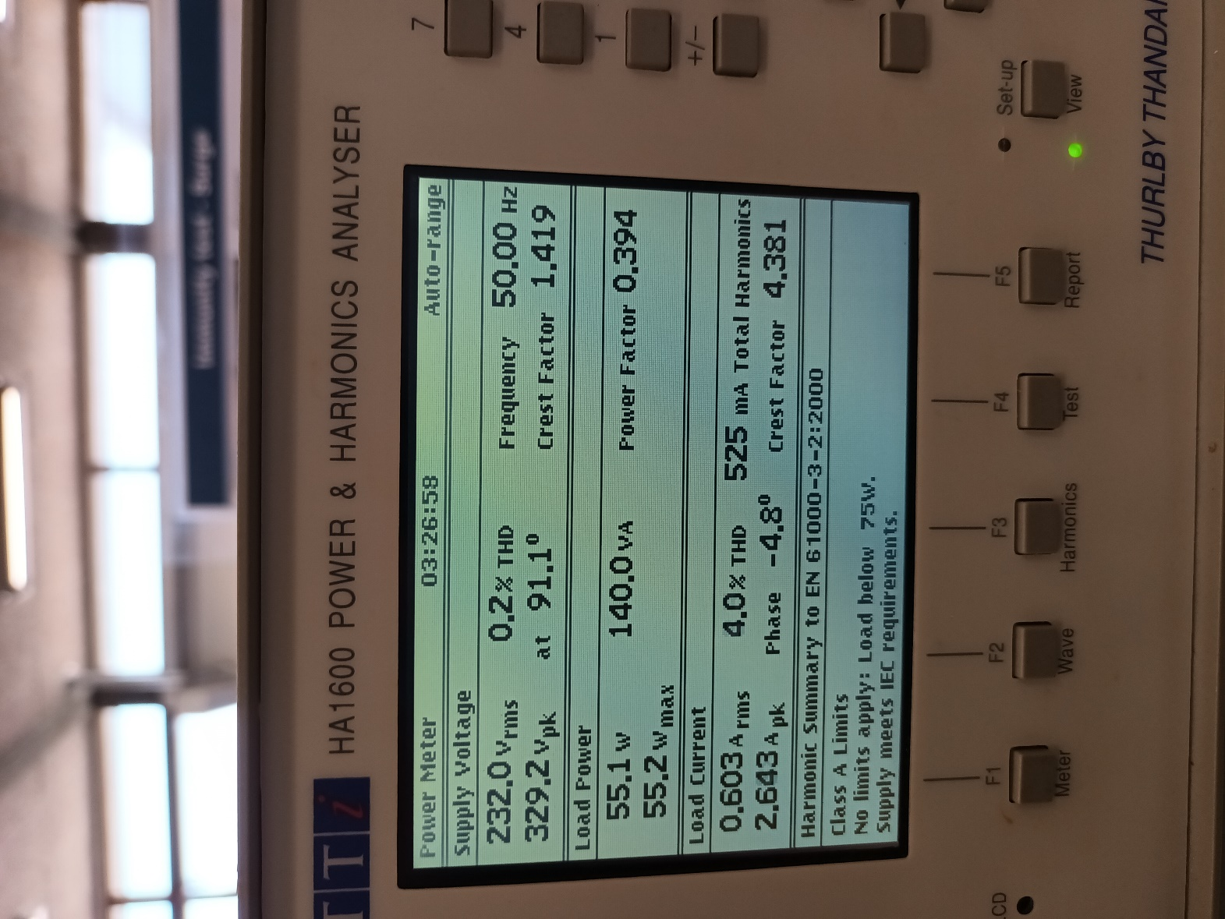
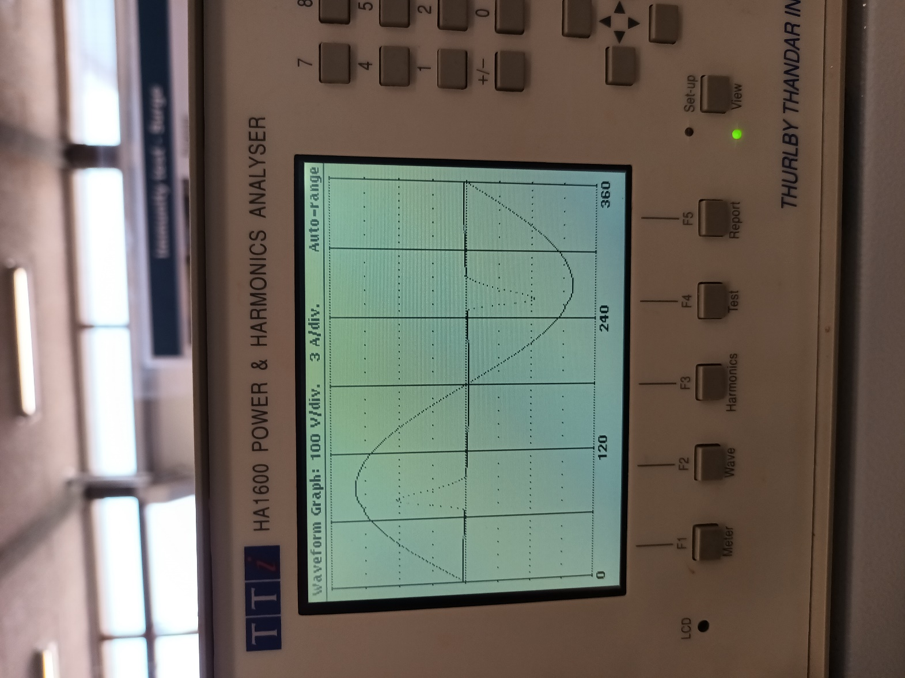
Voltage and current at 230 Vac
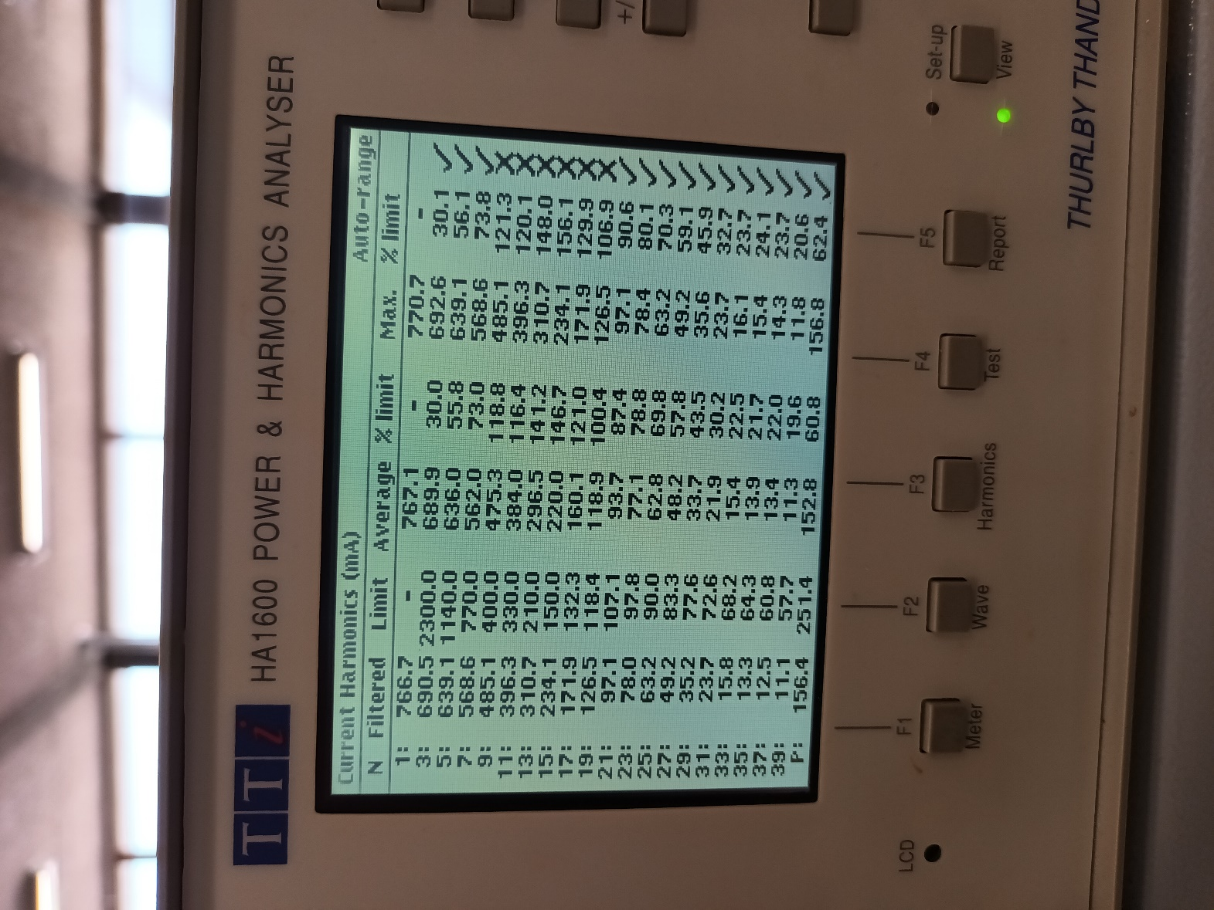
Table of harmonic distortion
Load 10A @ 14,5Vdc
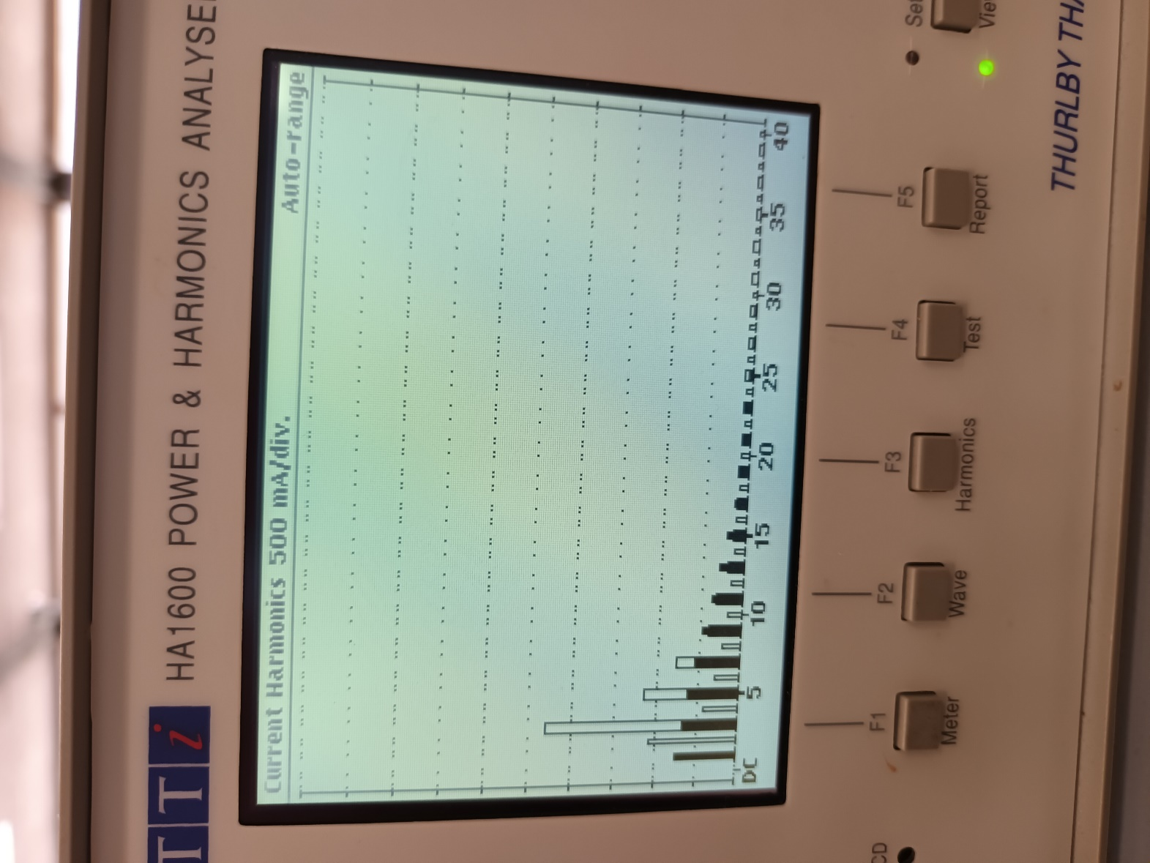
Harmonic distortion histogram.
Load 10A @ 14,5Vdc

Temperature measurement
During the above measurements, the units appeared to be very warm. For this reason thermal images of EUT 4053 were made. Ambient temperature was 23 deg. C
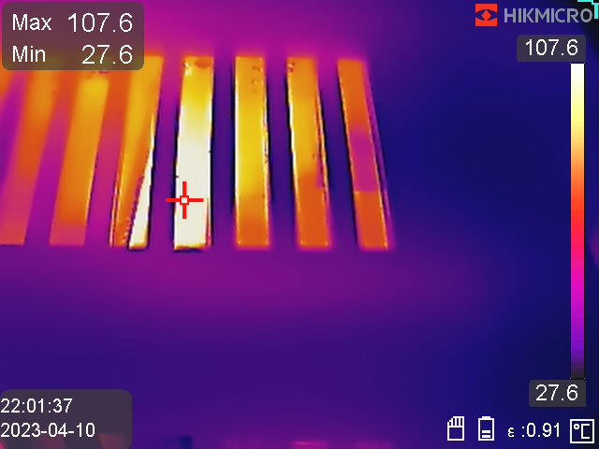
First measurement with unit in cabinet

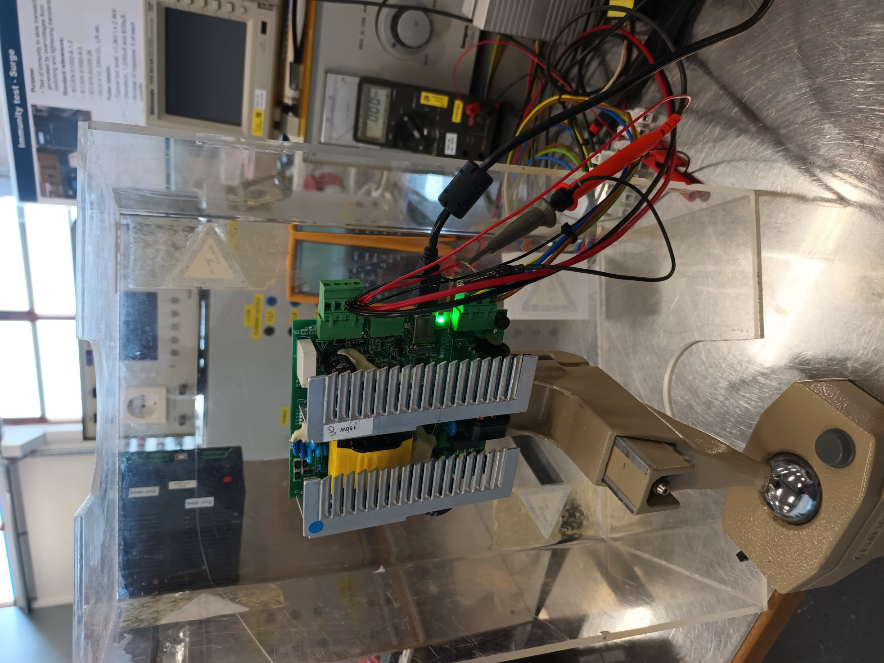
Tests on open PCB
(It has been noticed the unit is oriented up-side down.)
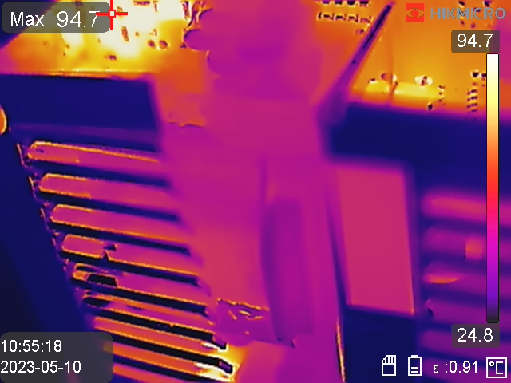
Hot spot at SMD resistors (primary side snubber and current sensing?)

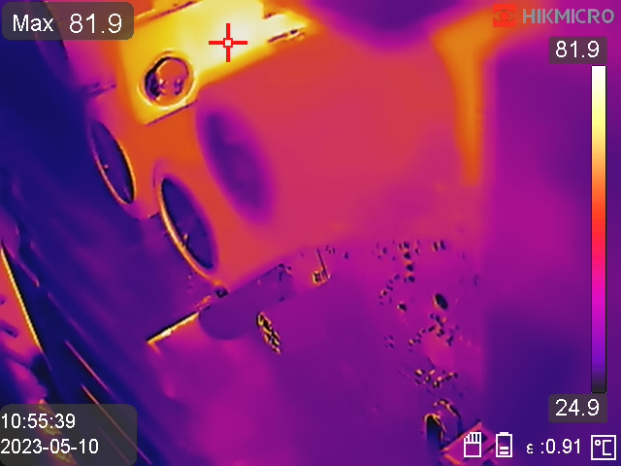
Rectifier MOSFET
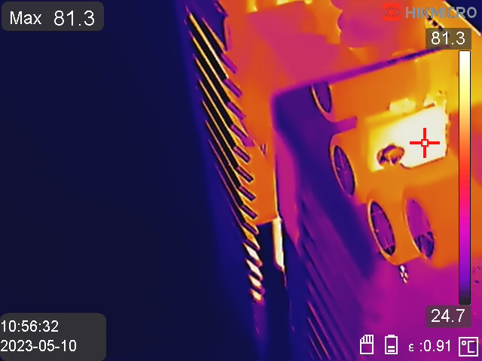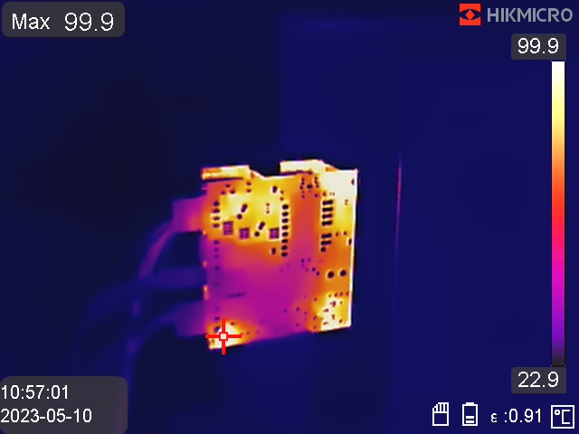
Backside of PCB
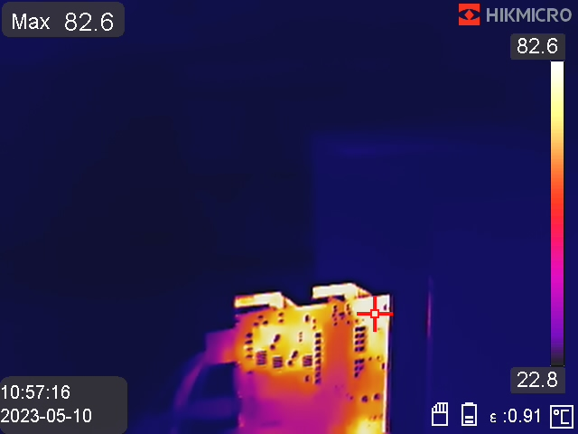
Backside of PCB

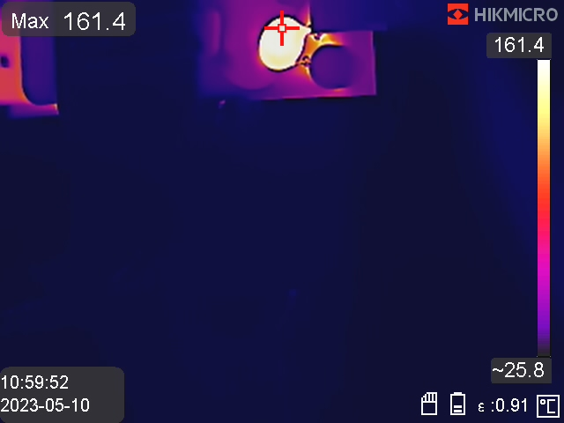
Inrush PTC
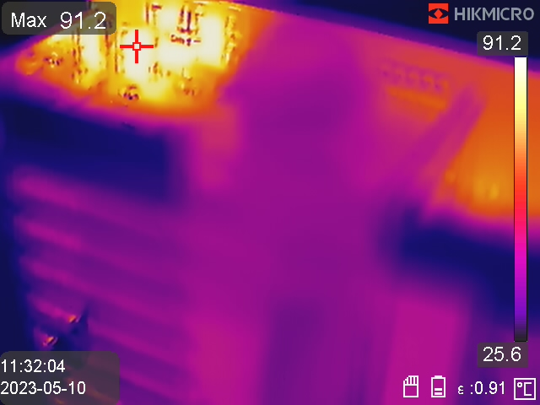
SMD power resistors

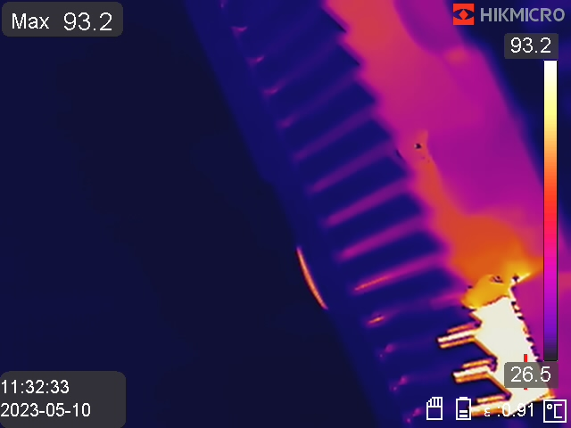
Mains rectifier bridge

